

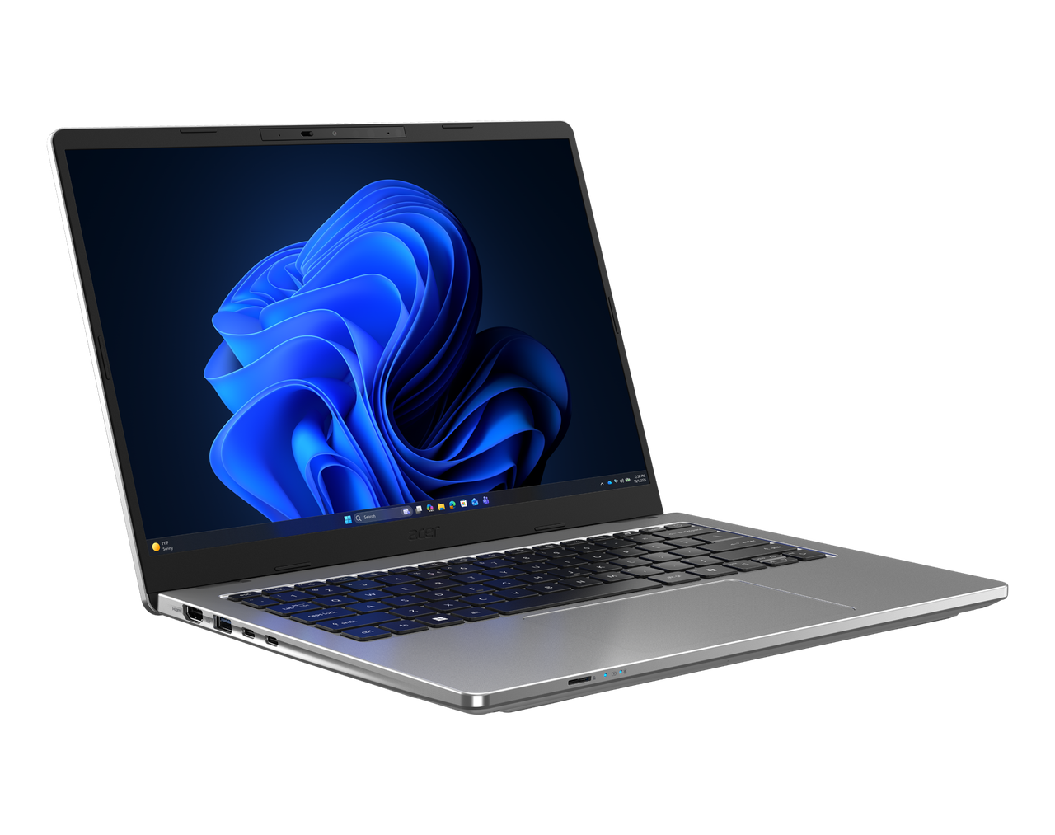
TravelMate P2 14 AI

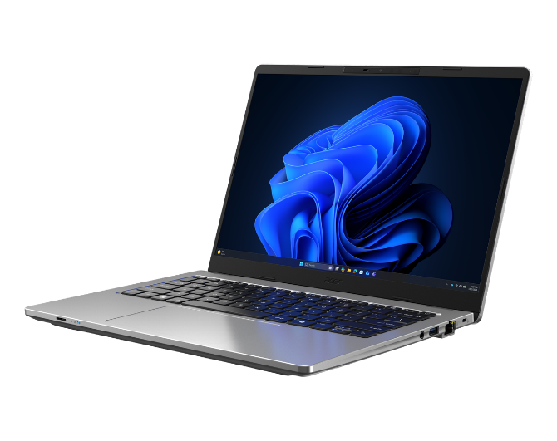
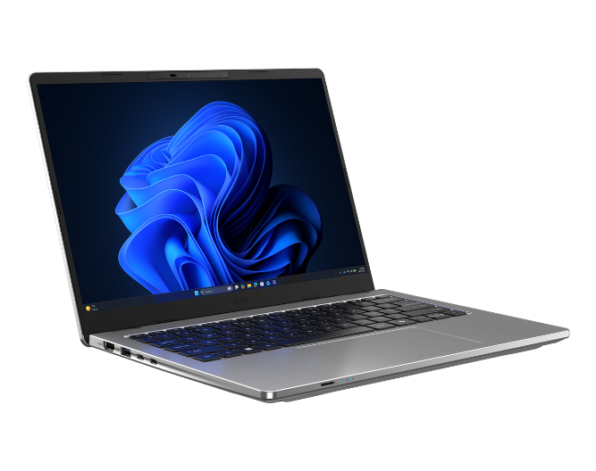
Product views | - Microphones  - Webcam shutter  - Webcam  - IR Sensor (optional)  - 14.0" display | - HDMI™ Port  - USB 3.2 Gen 1 port with power off USB charging  - Two USB® 4 Type-C ™ / Thunderbolt™ 4 ports |  |  |  |  | - MicroSD Card Reader  - Touchpad  - Keyboard  - Power Button |  |  |  |  |  |  | - Fingerprint reader (optional)  - Audio Jack  - USB 3.2 Gen 1 port  - RJ-45 port  - Kensington lock slot
Operating system¹ | Windows 11 Pro (Acer recommends Windows 11 Pro for business.)  Windows 11 Home
CPU and chipset¹ | P2214-57 | P214-57-TCO  •Intel® Core™ Ultra 5 processor 322  •Intel® Core™ Ultra 5 processor 332  •Intel® Core™ Ultra 7 processor 355  •Intel® Core™ Ultra 7 processor 365 |  |  |  |  |  |  |  |  |  |  | P214-77 | P214-77-TCO  •Intel® Core™ Ultra 7 processor 356H
Memory^{1, 2, 3} | Dual-channel DDR5 SDRAM support | Up to 5600 MT/s  Up to 64 GB of DDR5 system memory using two soDIMM modules
Display ⁴ | 14.0" display with IPS (In-Plane Switching) technology, WUXGA 1920 x 1200, Acer ComfyView™ LED-backlit TFT LCD, supporting 120Hz refresh rate.  •16:10 aspect ratio, color gamut sRGB 100% / 16:10 aspect ratio, color gamut NTSC 45%  •Wide viewing angle up to 170 degrees  •Mercury free, environment friendly
Graphics | Intel® Graphics Eligible
Audio | •DTS® Audio, featuring optimized bass response and micro-speaker distortion prevention  • Acer Purified.Voice technology with AI noise reduction with dual-mic array built-in microphones. Features include far-field pickup, dynamic noise reduction through neural network, adaptive beam forming, and pre-defined personal and conference call modes.  •High SNR DAC with 2.1 Vrms out capability and can driver high impedance headphone (up to 600 ohm) |  |  |  |  |  |  |  |  | • Acer TrueHarmony Technology for lower distortion, wider frequency range, headphone-like audio and powerful sound by Acer Ultra Boost Stereo Speaker Module  •Compatible with Cortana with Voice
Storage^{1, 6} | - 256 GB / 512 GB / 1 TB, PCIe Gen4, 16 Gb/s, NVMeSSD slot: 1
Webcam¹ | UFC with  Double T-Type USB 5M +IR Camera  Compatible with Windows only  2880 x 1800 Resolution  1800p 5M Video at 30 FPS with Temporal Noise Reduction  Staggered High Dynamic Range (SHDR)  Dual Mic (33 mm + 33 mm)  86 x 3.2 (4.2) x 3 mm  Blue glass lens  IR 940nm |  |  | UFC with  Double T-Type USB FHD Camera  Compatible with Windows only  1920 x 1080 resolution  1080p HD video at 30 fps with Temporal Noise Reduction  86 x 3.2 (4.2) x 3 mm  Blue glass lens  Dual Mic (33 mm + 33 mm)
Wireless and networking¹ | LAN  •Gigabit Ethernet  •Wake-on-LAN ready  •WPAN  •Supports Bluetooth LE Audio (LC3)  •Supports Bluetooth® 5.4 or above for Wi-Fi 7 wireless card  WLAN  •Intel® Wi-Fi 7 Wireless LAN  •802.11 a/b/g/n/ac/ax/be  •Band: 2.4 GHz, 5 GHz, and 6 GHz  •2x2 MIMO technology  •Intel® vPro® Enterprise |  |  |  | WWAN  •LTE FDD: B1, B2, B3, B4, B5, B7, B8, B12, B13, B14, B18, B19, B20, B25, B26, B28, B29, B32, B66, B71  •LTE TDD: B38, B39, B40, B41, B42, B43, B48  •Support up to LTE DL Cat.12  •LTE Data Rate: Maximum download 600 Mbps, upload 150 Mbps  •WCDMA: B1, B2, B4, B5, B6, B8, B9, B19  •WCDMA Data Rate: Maximum download 384 kbps, upload 384 kbps  •DC-HSPA+: Maximum download 42 Mbps  •WWAN/eSIM (optional)
Security | - Acer ProShield Plus security manager includes:  •Data Protection: File & Folder Encryption and Decryption, Personal Security Drive  •Data Removal: File Shredding  •Security Alert: Invalid Access Alert, Security Report Security |  |  |  |  |  |  |  |  | Discrete Trusted Platform Module (TPM) solution  BIOS user, supervisor, HDD(OPAL) password  Kensington lock (Nano-type)  Camera shutter
Dimensions and weight ^{1,7,8} | Dimensions  - 314.7 (W) x 228.4 (D) x 17.9/18.9 (H) mm (12.39 x 8.99 x 0.7/0.74 inches)  Weight |  |  |  |  |  |  |  |  |  | Weight  - 1.33 kg (2.93 lbs.) with 3-cell battery pack, WUXGA display
Power adapter and battery ¹ | Power adapter  100 W PD PCR 50%, TCO 10.0 AC adapter  •5 V / 3 A or 9 V / 3 A or 12 V / 3 A or 15 V / 3 A or 20 V / 5 A as output power  •108.0 (W) x 56.0 (D) x 26.5 (H) mm  •296 g ± 5% with 150 cm DC cable  •Black color with Acer logo  •Brick type AC pins  •Paper sleeve packaging |  | 65 W PD PCR 50%, TCO 10.0 AC adapter  •5 V / 3 A or 9 V / 3 A or 12 V / 3 A or 15 V / 3 A or 20 V / 3.25 A as output power  •90.0 (W) x 51.0 (D) x 28.5 (H) mm  •192g ± 10% with 150 cm DC cable  •Black color with Acer logo  •Brick type AC pins  •Paper sleeve packaging |  |  |  |  | P214-57 | P214-57-TCO  Battery  •53 Wh 3-cell Li-ion battery  •Supports Fast Charging technology  •For models with WUXGA Panel + SSD  Battery life:  •Up to 9.5 hours (based on MobileMark® 30 test results)  •Up to 25 hours (based on video playback test results)  •Up to 14 hours (based on web browsing test results) |  |  |  |  | •65 Wh 3-cell Li-ion battery  •Supports Fast Charging technology  •For models with WUXGA Panel + SSD  •Battery life:  •Up to 11.5 hours (based on •MobileMark® 30 test results)  •Up to 31 hours (based on video playback test results)  vUp to 17 hours (based on web browsing test results) |  |  |  | P214-77 | P214-77-TCO  Battery  •53 Wh 3-cell Li-ion battery  •Supports Fast Charging technology  •For models with WUXGA Panel + SSD  •Battery life:  •Up to 8.5 hours (based on •  MobileMark® 2030 test results)  •Up to 17 hours (based on video playback test results)  •Up to 10.5 hours (based on web browsing test results) |  | •65 Wh 3-cell Li-ion battery  •Supports Fast Charging technology  •For models with WUXGA Panel + SSD  •Battery life:  •Up to 10.5 hours (based on •MobileMark® 2030 test results)  •Up to 21 hours (based on video playback test results)  •Up to 12 hours (based on web browsing test results)
Input and control | Keyboard:  • 80-/81-/84-key Acer keyboard layout with international language support including indicators of CapsLock and F4/Microphone mute  • 80-/81-/84-key Acer backlight keyboard layout with international language support including indicators of CapsLock and F4/Microphone mute (Notes: Spill Resistant Keyboard based on MIL-STD-810H Method506.6 Procedure III Drip test  Control Keys:  - TravelMate Sense Key Copilot Key |  |  |  |  |  |  |  |  | Touchpad:  Multi-gesture touchpad, supporting two-finger scroll; pinch; gestures to open Cortana, Action Center, multitasking; application commands  •Microsoft Precision Touchpad certification  •Windows Hello Certification  •OceanGlass™  Touchpad:  Multi-gesture secure touchpad, supporting two-finger scroll; pinch; gestures to open Cortana, Action Center, multitasking; Fingerprint application commands  •Microsoft Precision Touchpad certification  •Windows Hello Certification  •OceanGlass™ Touchpad
Windows Desktop Apps⁹ | Acer app  - Acer AI Image Generator  - Acer LiveArt  - Acer ORD Service |  |  |  |  | - • Acer AI Image Generator  - Acer QuickPanel  - TravelMate Sense  - Acer AI Image Generator |  |  |  |  |  |  |  |  |  | Productivity  •IrisGo
System compliance | TMP214-57 / TMP214-77  - ENERGY STAR®  - Wi-Fi®  - EPEAT®registered |  |  |  |  | TMP214-57-TCO/ TMP214-77-TCO  - EPEAT®registered  - ENERGY STAR®  - Wi-Fi®  - TCO Certified
Warranty | One-year International Travelers Warranty (ITW)

1. Specifications vary depending on model.
2. Shared system memory may be allocated to support graphics, depending on system memory size and
other factors. Actual system memory available to the operating system will be reduced by any memory
used by the graphics solution and resources required by the operating environment.
3. Memory speed may vary, depending on the CPU, chipset or memory fitted.
4. All brands and product names mentioned herein include trademarks of their respective companies and
are used solely to describe or identify the products.
5. Not all features indicated are supported on all SKUs
6. 1 GB is 1 billion bytes. Actual formatted capacity is less and may vary depending on preloaded materials
and operating environment. Acer Recovery Management uses a portion of the stated hard disk capacity
as dedicated backup space.
7. Minor variations in system dimensions are possible due to the manufacturing process.
8. Weight may vary depending on product configuration, vendor components, manufacturing variability, and
selected options.
9. Listed battery life is based on testing using video playback. The test clip loops and continues to run,
without interruption or any other inputs, until the battery is drained. Stated battery life is for comparison
purpose only. Actual battery life varies by model, configuration, applications, video chip format and
features used. A battery's maximum capacity decreases with time and use. Battery life test configuration:
Intel® ULTRA 5 (Series 3), Intel® Graphics, WUXGA, SSD only, 16GB of DDR5 memory. Battery life test
condition: LCD brightness 150 nits, connected headphones, WLAN off, Bluetooth off and Better Battery
Mode on.
10. Listed battery life is based on testing using Web browsing. The test clip loops the loading of 50 selected
websites using Microsoft Edge every 30 seconds, until the battery is drained. Stated battery life is for
comparison purpose only. Actual battery life varies by model, configuration, applications, video chip
format and features used. A battery's maximum capacity decreases with time and use. Battery life test
configuration: Intel® ULTRA 5 (Series 3), Intel® Graphics, WUXGA, SSD only, 16GB of DDR5 memory.
Battery life test condition: 100 nits LCD brightness, 50% speaker volume, WLAN on, Bluetooth on, no
WW direct Internet connection.
11. Actual battery life may vary considerably by specifications, depending on product model, configuration,
applications, power management settings, operating conditions, and features utilized. Performance
variation also arises based on components in use, which includes but is not limited to the processor,
RAM capacity, storage, display and resolution, etc.
12. Bundled software may vary depending on hardware configuration, OS and regional availability.
13. EPEAT® registration varies by country. See http://www.epeat.net/ for registration status for each country.

Note: This specification is based on TravelMate P214-57 Specifications (v1-0-1), TravelMate P214-57-TCO Specifications (v1-0-1), TravelMate P214-77 Specifications (v1-0-1), TravelMate P214-77-TCO Specifications (v1-0-1)
13
14
15
17
16
1
2
4
5
7
6
8
3
10
12
11
9
SPECIFICATIONS TravelMate P2 14 AI P214-57 | P214-57-TCO | P214-77 | P214-77-TCO

